STATIC ROUTING TOPOLOGY
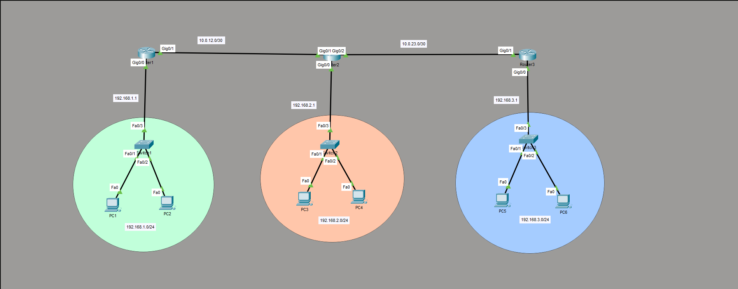

ROUTER 1
- show ip interface brief
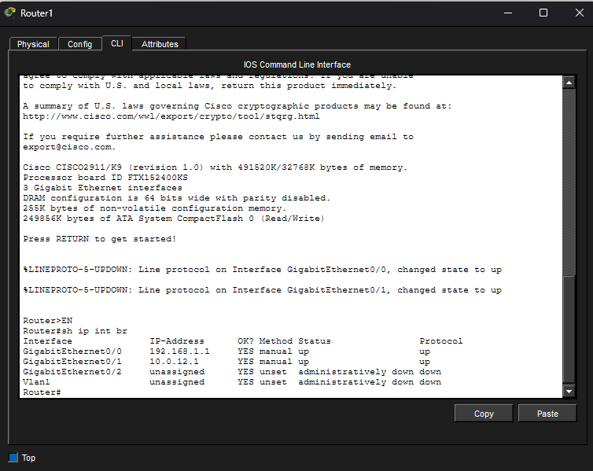

- show ip route
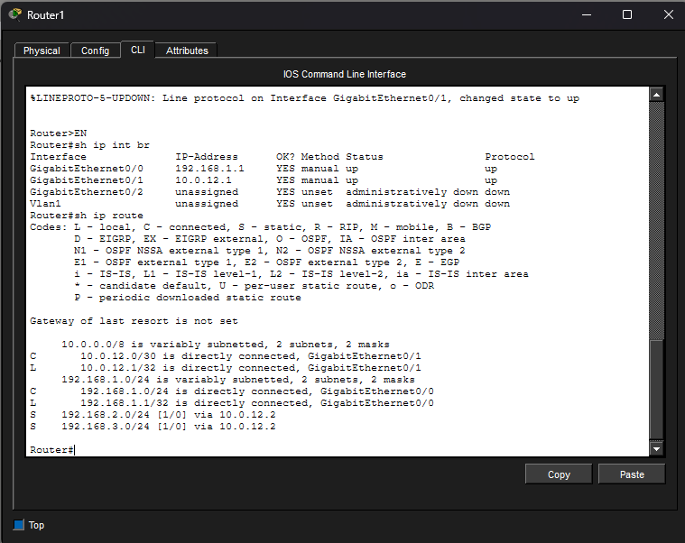
ROUTER 2
- show ip interface brief
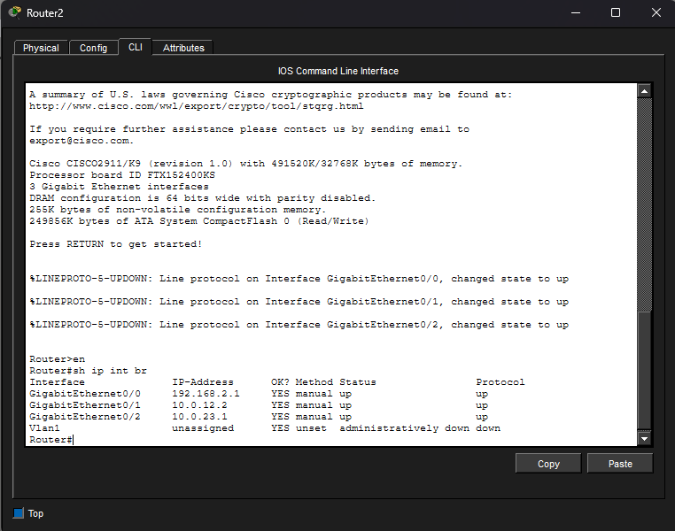
- show ip route
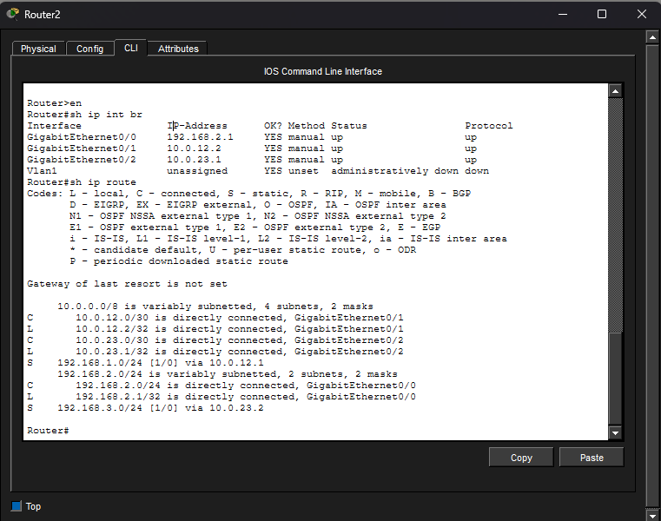
ROUTER 3
- show ip interface brief
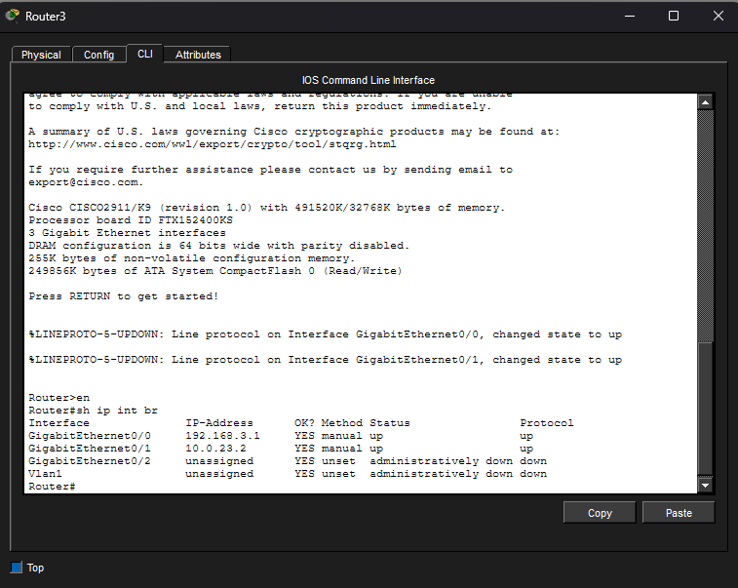
- show ip route
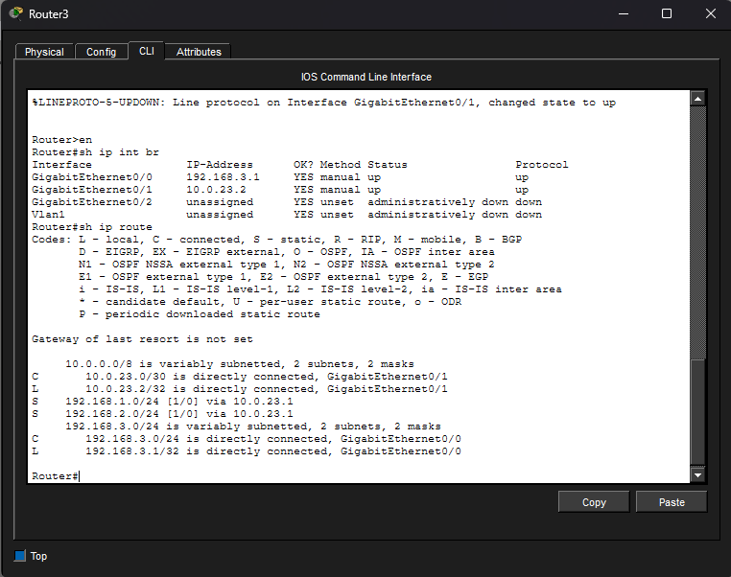
PC1 (192.168.1.0/24) to PC3 (192.168.2.0/24)
- ping
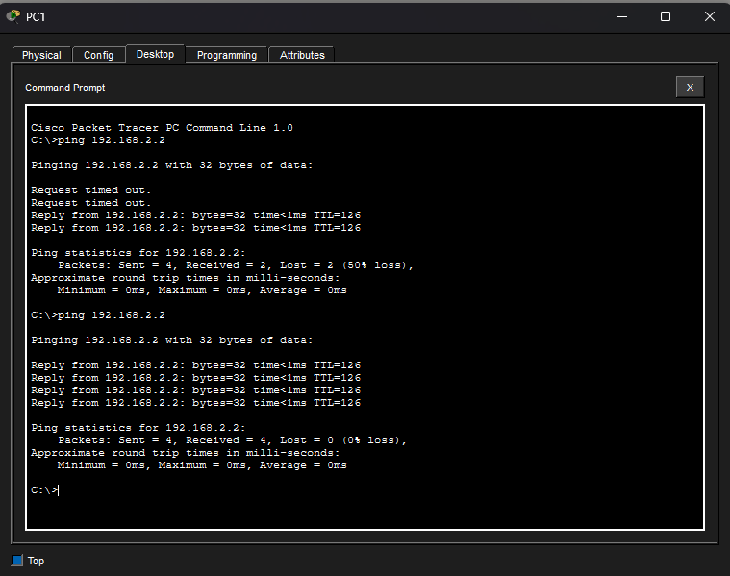
PC1 (192.168.1.0/24) to PC5 (192.168.3.0/24)
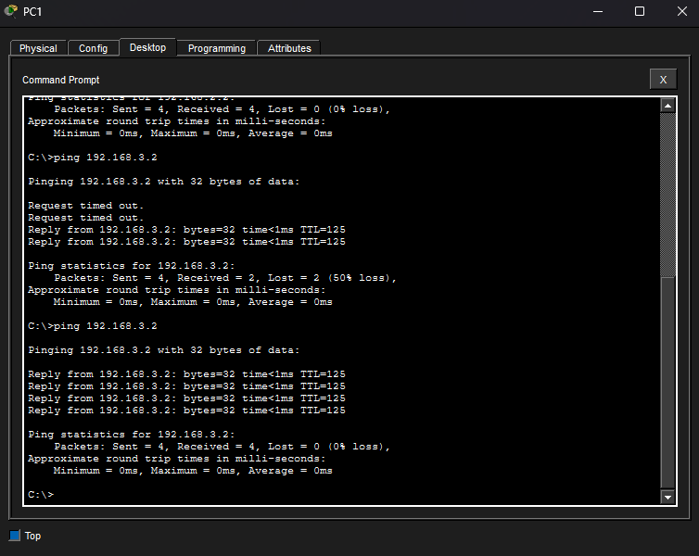
PC5 (192.168.3.0/24) to PC1 (192.168.1.0/24)
